

Inaugural New York to Barcelona Race Setting Transatlantic Sailing Record

April 19, 2010

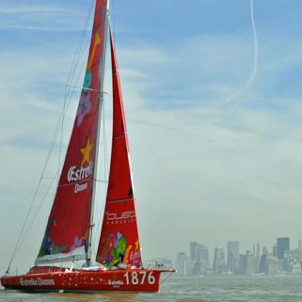
When traveling from New York to Barcelona, 15 days would hardly seem like record time, unless the mode of transport was sailing.
The first New York to Barcelona transoceanic sailing record is now underway and the two competing boats are expected to arrive in the Spanish port city this week.
Nancy Lazarus goes behind the scenes of the event.
The 3,750 nautical mile race between one American and one Spanish sponsored boat will establish an official sailing record between the cities.
The two part event included a warm-up regatta in New York harbor on April 3 in which each boat won one race. The official record began on April 8 and while the the estimated race time was 18 to 22 days, the race has been proceeding at a faster pace, and the boats are already along the Spanish coast.
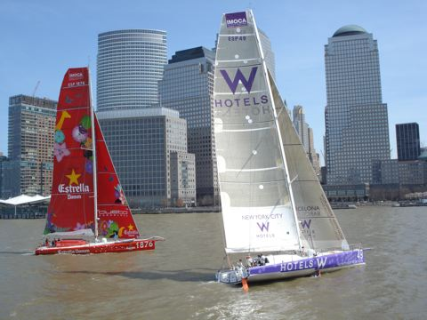
The race aims to strengthen partnerships between the cities, and each boat has two Spanish and one American crew member on board. The idea for the event came about because there is no official sailing record between New York City and Barcelona. Since both are cosmopolitan cities, cultural centers and major ports, they were natural choices to participate.
Josep Gonzalez is project manager at Fundacio Navegado Oceanica Barcelona, one of the main organizers. He explained during an interview before the regatta, “The goal is to promote both cities as destinations for international sports events and tourism. In the longer term we want to encourage adults’ and children’s interest in sailing. We’re trying to position the sport as an alternative to soccer, which is so popular.”
The boats’ two sponsors are W Hotels, Starwood’s boutique hotel brand based in New York, and Estrella Damm, a beer brand produced by S.A. Damm, a Barcelona brewery. According to Gonzalez, “Both sponsors were attracted to sailing because the sport protects the environment.”
W Hotels wants to gain exposure for its first hotel in Western Europe, located on the waterfront in Barcelona.
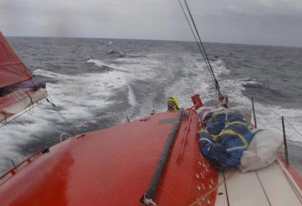
The race’s daily progress seems closer than usual, thanks to the extensive use of digital technology. Various interactive tools are being used in an effort to keep the media informed and to teach school children about sailing. The Web site, www.ny-bcn.org, will provide the latest race updates. The sailors are also Twittering from the boats (http://twitter.com/RecordNYBCN).
In addition, Gonzalez said “There will be daily video-conferences between the crew and the media as well as between the sailors and students. Online spectators will be able to see what’s happening on the boats in real-time, including any problems the sailors experience along the route.” They can also follow the race on Facebook.
After all the preparation, Gonzalez is not overly concerned about nature’s impact on the race. He said, “The weather may be an issue, but that’s part of sailing.”
By Nancy Lazarus for PeterGreenberg.com. Visit Nancy on the Web at www.nlmarketresearch.com.

